**Elevator**

*Barbie You Can Be Anything - Pet Vet* is the second installment in the *You Can Be Anything* mobile app line. In Pet Vet, users collect and wield a variety of tools and accessories to diagnose, treat, groom and dress Barbie and her pals’ pets. It’s an engaging vet-simulation, dress-up, collection and caretaking experience geared for G8-12.

**User Experience**

Pet Vet’s UX is broken into 5 phases ; Start, Diagnosis, Treatment, Grooming and Dress-up / Finish.

1. **Start Phase** – In the Start Phase, users are greeted by the Title Screen where the *Daily Reward* pop-up awards them a coin for each day of consecutive gameplay. Users collect their coin(s) and enter the Pet Vet where the game begins. Users choose a pet to treat and are presented with a fly-in telling them a fun fact about that pet (accompanied by voiceover). We then enter the Pet Vet office, where Nikki’s portrait greets our users and the Pet Chart pop-up appears. The Pet Chart both informs users how gameplay will ensue and tracks progress along the way.
2. **Diagnosis Phase** – Each play-through generates between 1 and 3 random ailments to diagnose and subsequently treat. In the Diagnostic Phase, users meet our Pet VetNikki who walks us through employing the diagnostic tools :
   1. X-Ray – Users move an X-Ray screen around the pet to detect problems. Healthy bones are tinted slightly green, any broken bones will turn red. A meter measures progress – if the animal is healthy, the meter will fill upon 100% of the animal being scanned; if there is a broken bone, the user must hold the X-Ray over the broken bone until the meter is filled.
   2. Thermometer – Users must affix the thermometer over the pet’s mouth to take its temperature. A timed meter will fill to indicate progress / completion.
   3. Stethoscope – Similarly to the Thermometer, the Stethoscope must be held in place (over the pet’s heart) until the timed meter is filled.

Premium versions of each tool are available for purchase (with daily reward coins, ad views or in bundles via the in-app store), each of which completes the task more quickly and with additional fun visual effects. There are also fantastical versions of the tools for our Fantasy Pets. Between diagnostic steps, the Pet Chart appears to record the specific ailments for this session (denoted by large, red X’s on our Pet Chart), and Nikki gives us helpful pointers along the way about our impaired pet pals.

1. **Treatment Phase** – Depending on the ailment(s) recorded on our Pet Chart, the appropriate Treatment Tool is presented for each step :
   1. Bandages - Broken bones revealed by the X-ray must be bandaged. Users drag a finger across / over the limb to bandage it. 3 bandages must be applied to complete this step.
   2. Ice Packs – For fevers exposed by the Thermometer users must drag and hold an Ice Pack over the forehead of the feverous pet. A meter indicates progress / completion.
   3. Vitamins - Chest pains identified by the Stethoscope require Vitamins. Users drag a bottle over the pet to deliver a dose of Vitamins.

Only specifically-diagnosed conditions trigger the corresponding treatment step / tool. Nikki is there the whole way through, cheering us on and giving us tips as to the mechanics of each tool. When an ailment is successfully treated, our Pet Chart appears, the red X mark is turned to a green check, and Nikki trills her congratulations. Our Pet Chart informs us next on our to-do list is grooming the pet.

1. **Grooming Phase** – The Grooming Phase is identical every play-through. As in the Diagnosis Phase, premium versions of each tool are available for purchase to complete the job quicker and more satisfyingly. Nikkie encourages us as always and instructs on how to best use each tool :
   1. Shampoo – Users scrub their pet with shampoo in order to fill a meter that denotes when the pet is fully lathered-up (premium version features bigger, more bubbly suds)
   2. Rinse – Users choose between the Spray Bottle and the Shower Head (premium) to rinse their pets off. Once the suds are all washed away, we’re ready to dry our pet.
   3. Dry – Selecting between the Hand-towel and Blow Dryer, users move the tool over and around the pet, filling a meter to completion.
   4. Brush – Brushing entails dragging a finger across the pet, combing out the tangles of the touched area. Again, a meter tracks users’ progress.

When grooming is complete, gameplay is put on hold for a moment while Nikki congratulates us and our healthy, happy (and sparkly-clean) pet animates excitedly for us. Users “pet” the pet by touching it, triggering the happy animation as many times as they please. When ready to proceed users tap the check button to continue on to Phase 5 – Dress-up (Finish)

1. **Dress-up / Finish** – Nikki reminds us the pet’s owner has requested specific adornments for their healthy, groomed pet. The Pet Chart appears reiterating what the requested accessories are, and tabbed-slider appears at the foot of the screen featuring our accessory categories / selections. Users drag & drop / rotate & scale accessories onto the pet. Users may use as many accessories as they like, but they must make use of the specified accessories in order to successfully complete the appointment and earn a star for that pet (stars only featured in Pet Vet mode). When users are satisfied with the appearance of their pet, they press the check button and, once again, the Pet Chart appears to record our progress. Our Pet photo pop-up appears and a snapshot is taken and saved to the game’s internal photo gallery. Finally, our Summary / Reward pop-up appears presenting us with our star (or not) and the ability to save the photo to our device’s camera roll. Nikki congratulates us according to our performance.

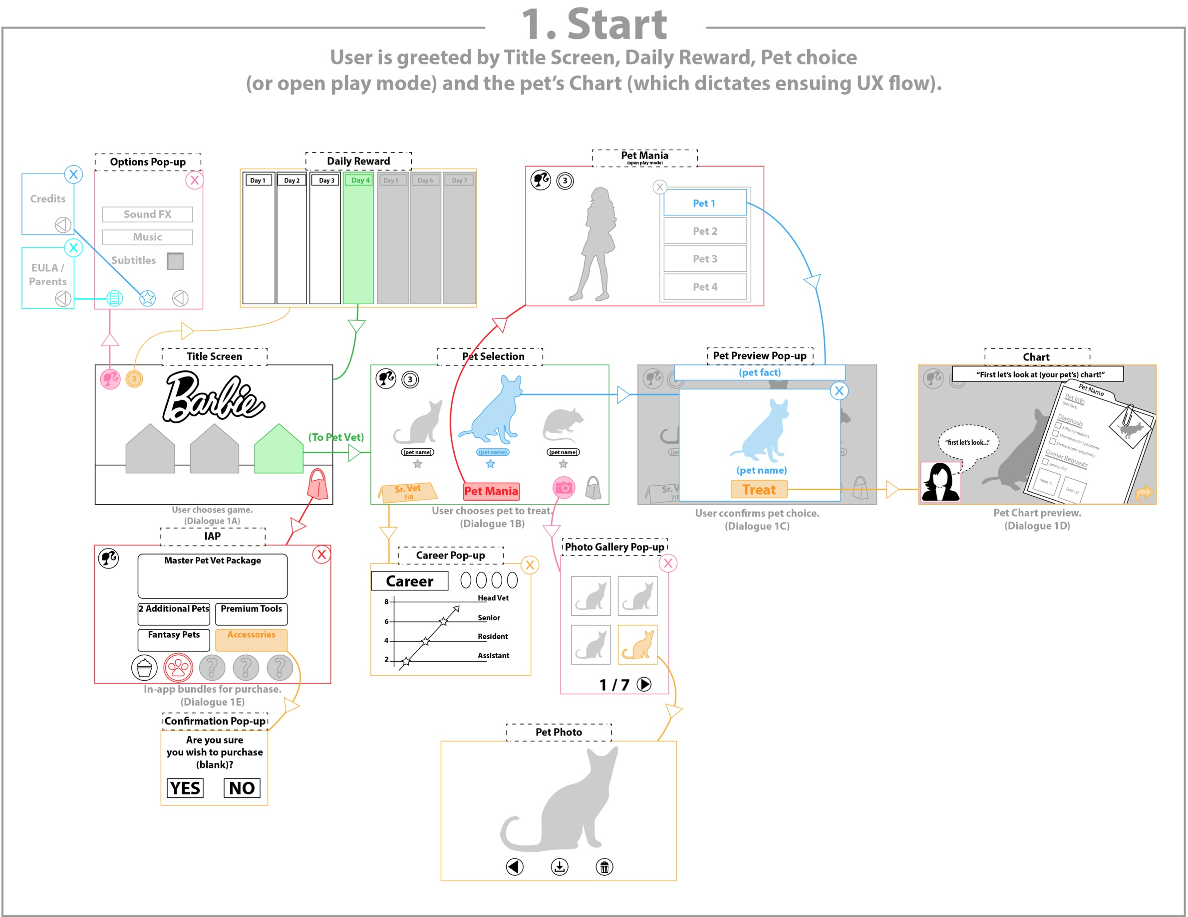

**Monetization**

Pet Vet features an in-app store that will contain purchasable bundles of pets, tools and items. Our recommendation is to grant users access to 2 initial pets, pay-gating another 2 (along with premium tools / accessories).

|  |  |  |  |
| --- | --- | --- | --- |
| **Bundle** | **Price** | **Pets Unlocked** | **Tools / Accessories Unlocked** |
| Pets Galore Bundle | $9.99 | All | All Tools |
| All Tools Bundle | $3.99 | N/A | All Premium Tools |
| Additional Pets | $3.99 | 2 Regular Pets | Accessory Bundle 1 |
| Fantasy Pet Bundle | $4.99 | 4 Fantasy Pets | Accessory Bundle 2 |
| Fantastic Fashion Bundle | $2.99 | N/A | All Accessories |

* In-app currency is collected at the beginning of every session, where the Daily Reward pop-up greets return-users. 1 Barbie Coin is awarded each day, which can be used to unlock 1-time uses of premium tools in gameplay.
* In-app ads can also be viewed in exchange for Barbie Coins or Premium Tool use.

**Vet Level**

A player’s *Vet Level* is a reflection of how many stars they have amassed successfully treating, grooming and dressing pets. The Vet Level is observable at any point in the game, either via the options menu. Only users who treat all 8 pets can obtain Senior Vet status.



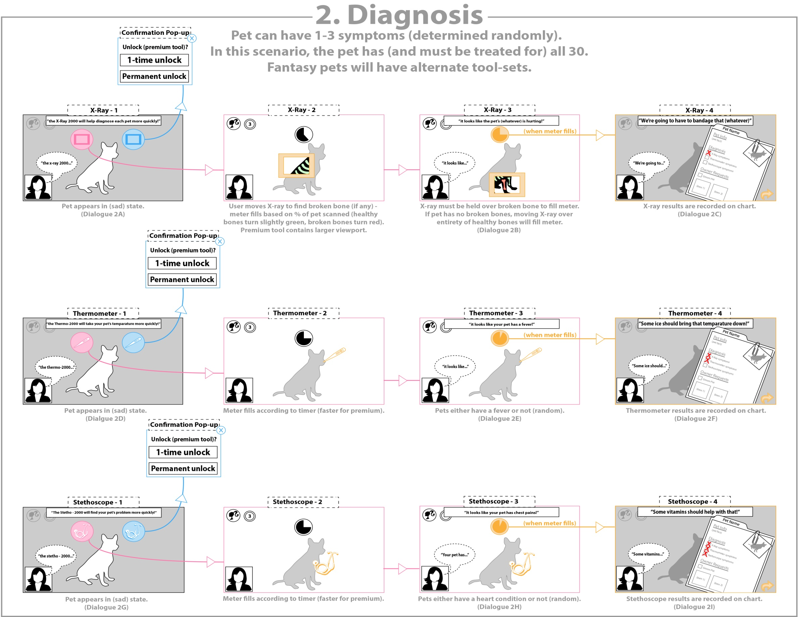

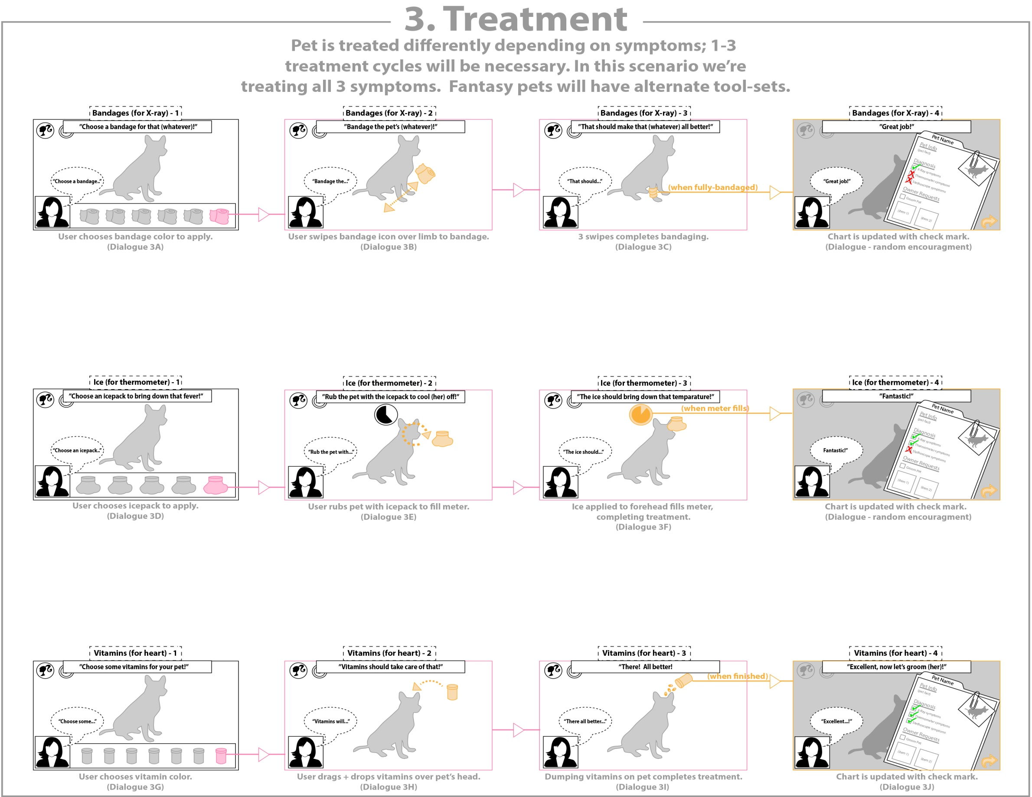

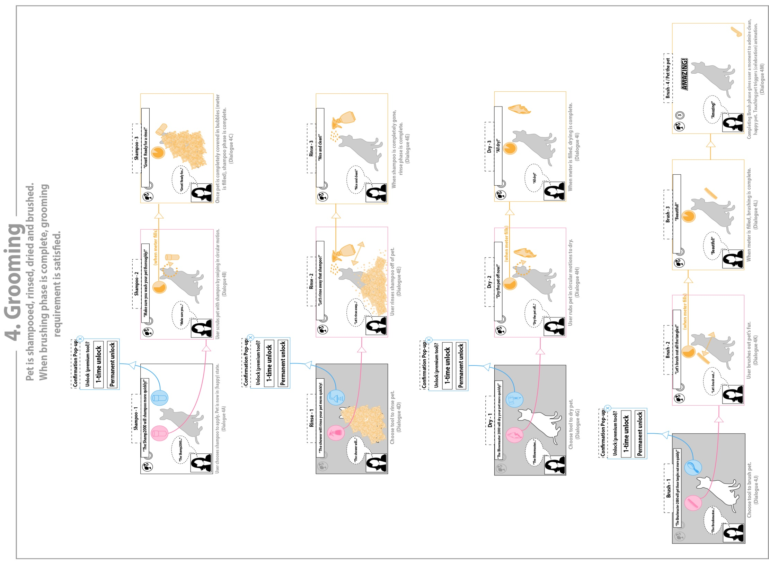

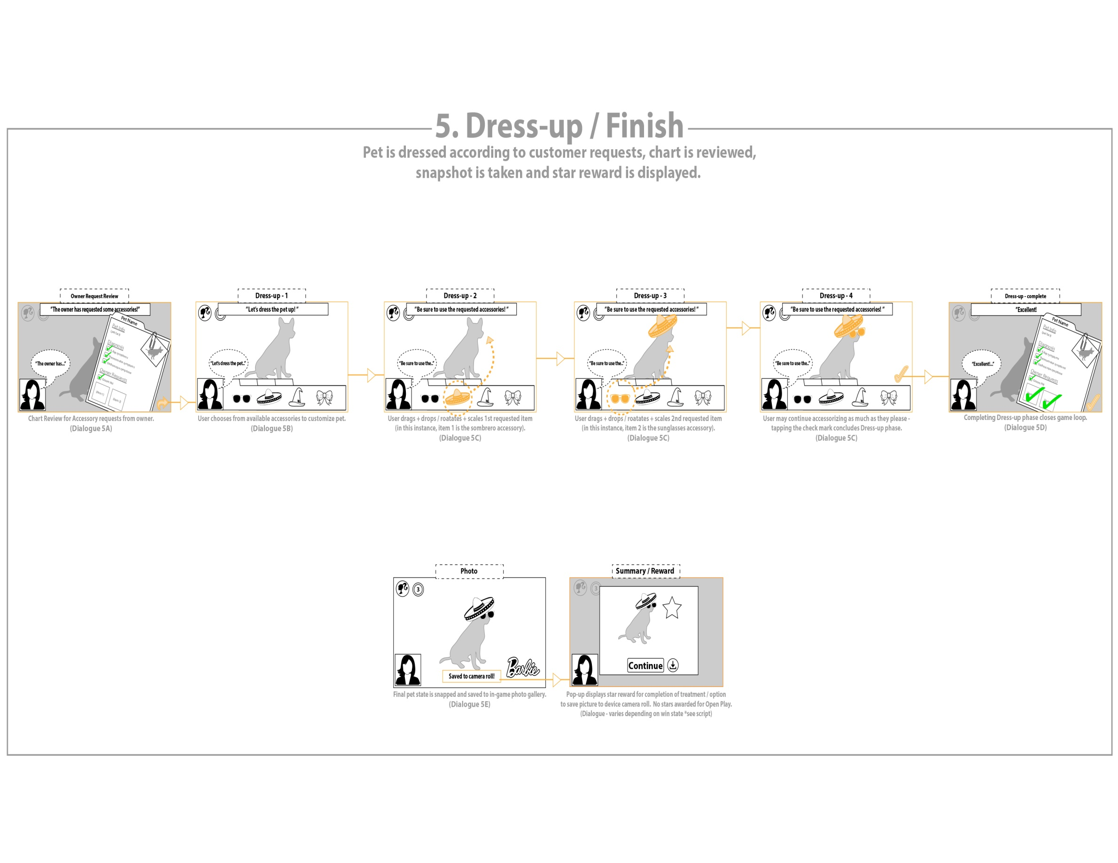

**Barbie BJE – Pet Vet**

**Nikki Voiceover / Copy**

**Phase 1. Title Screen - voiceover that greets users at Title Screen**

* 1A. “Welcome to Barbie You Can Be Anything!”

**Pet Select - voiceover at Pet Select**

* 1B. "Help each of the different pet to earn stars"

**Pet Select - once pet is selected**

* 1C. (trivia info about the animal, 3 for each pet)
* 1D. “First, let’s look at (pet’s) chart!”

**In-App Store - (subject to change until bundles are confirmed)**

- 1E. e.g. "The all pets bundle will unlock all the pets"

- 1E. e.g. "The tools bundle will unlock all the tools"

- 1E. e.g. “The All Pet's Bundle will unlock all of the locked pets!”

**Phase 2. Diagnosis – each step in treatment is accompanied by a blurb**

**X-Ray / (Fantasy Pet Tool):**

* 2A. “The X-Ray 2000 will help diagnose each pet more quickly!”
* 2B. “It looks like (pet’s) leg is hurt!”
* 2B. “It looks like (pet’s) arm is hurt!”
* 2B. “It looks like (pet’s) tail is hurt!”
* 2C. “We’re going to have to bandage that leg!”
* 2C. “We’re going to have to bandage that arm!”
* 2C. “We’re going to have to bandage that tail”

**Thermometer / (Fantasy Pet Tool):**

* 2D. “The Thermo-2000 will take (pet’s) temperature more quickly!”
* 2E. “It looks like (pet) has a fever!”
* 2F. “Some ice should bring that temperature down!”

**Stethoscope / (Fantasy Pet Tool):**

* 2G. “The Stetho-2000 will find (pet’s) problem more quickly!”
* 2H. “It looks like your (pet) has chest pains!”
* 2I. “Some vitamins should help with that!”

**Phase 3. Treatment – each step in treatment is accompanied by a blurb**

**Bandages / (Fantasy Pet Tool):**

* 3A. “Choose a bandage for that leg!”
* 3A. “Choose a bandage for that arm!”
* 3A. “Choose a bandage for that tail!”
* 3B. “Bandage (pet’s) leg!”
* 3B. “Bandage (pet’s) arm!”
* 3B. “Bandage (pet’s) tail!”
* 3C. “That should make that leg all better!”
* 3C. “That should make that arm all better!”
* 3C. “That should make that tail all better!”

**Ice Pack / (Fantasy Pet Tool):**

* 3D. “Choose an icepack to bring down that fever!”
* 3E. “Rub the pet with the icepack to cool (her) off!”
* 3F. “Some ice should bring that temperature down!”

**Vitamins / (Fantasy Pet Tool):**

* 3G. “Choose some vitamins for (pet)!”
* 3H. “Some vitamins should help (pet’s) chest pains!”
* 3I. “There, all better!”
* 3J. “Excellent, now let’s groom (her)!”

**Phase 4. Grooming – each step in treatment is accompanied by a blurb**

**Shampoo :**

* 4A. “The Shamp-2000 will lather (pet) more quickly!”
* 4B. “Make sure you wash (pet) thoroghly!”
* 4C. “Great! Ready for a rinse!”

**Rinse :**

* 4D. “The Shower-2000 will rinse (pet) more quickly!”
* 4E. “Let’s rinse away that shampoo!”
* 4F. “Nice and clean! Time to dry!”

**Dry :**

* 4G. “The Blowmaster-2000 will dry (pet) more quickly!”
* 4H. “Now let’s get (pet) nice and dry!”
* 4I. “All dry!”

**Brush :**

* 4J. “The Brushmaster-2000 will get those tangles out more quickly!”
* 4K. “Let’s brush out all the tangles!”
* 4L. “Beautiful!”
* 4M. “Amazing!”

**Phase 5. Dress-up – each step in treatment is accompanied by a blurb**

**Dress-up :**

* 5A. “(Owner) has requested some accessories!”
* 5B. “Let’s dress (pet) up!”
* 5C. “Be sure to use the requested accessories!”
* 5D. “Excellent!”
* 5E. “Awe! (She) looks adorable!

**Phase 5. Conclusion - Nikki summarizes user progress**

**Success : (these comments are always accompanied with “You’ve earned a star!”**

* “Totally amazing!”
* “Keep up the great work!”
* “You did amazing!”
* “Great job, doll!”
* “You’re really learning quickly!”
* “Perfect job!”
* “Congratulations!”
* * “You’ve earned a star!”

**Incomplete :**

* “Let’s try that again!”
* “Keep at it!”
* “Give it another shot, you can do it!”
* “You were so close!”

**Encouragements - responses to successful completion of any step (e.g. applying ice pack successfully)**

* “Great!”
* “Perfect!”
* “Amaze!”
* “Spectacular!”
* “Outstanding!”
* “Wow!”
* “Way to go!”
* “Yay!”
* “Nice!”

**Intermittent efforts - random response to user input (e.g. user touches pet to shampoo)**

- *Giggle 1

- *Giggle 2

- *Giggle

- *Laugh 1

- *Laugh 2

- *Laugh 3